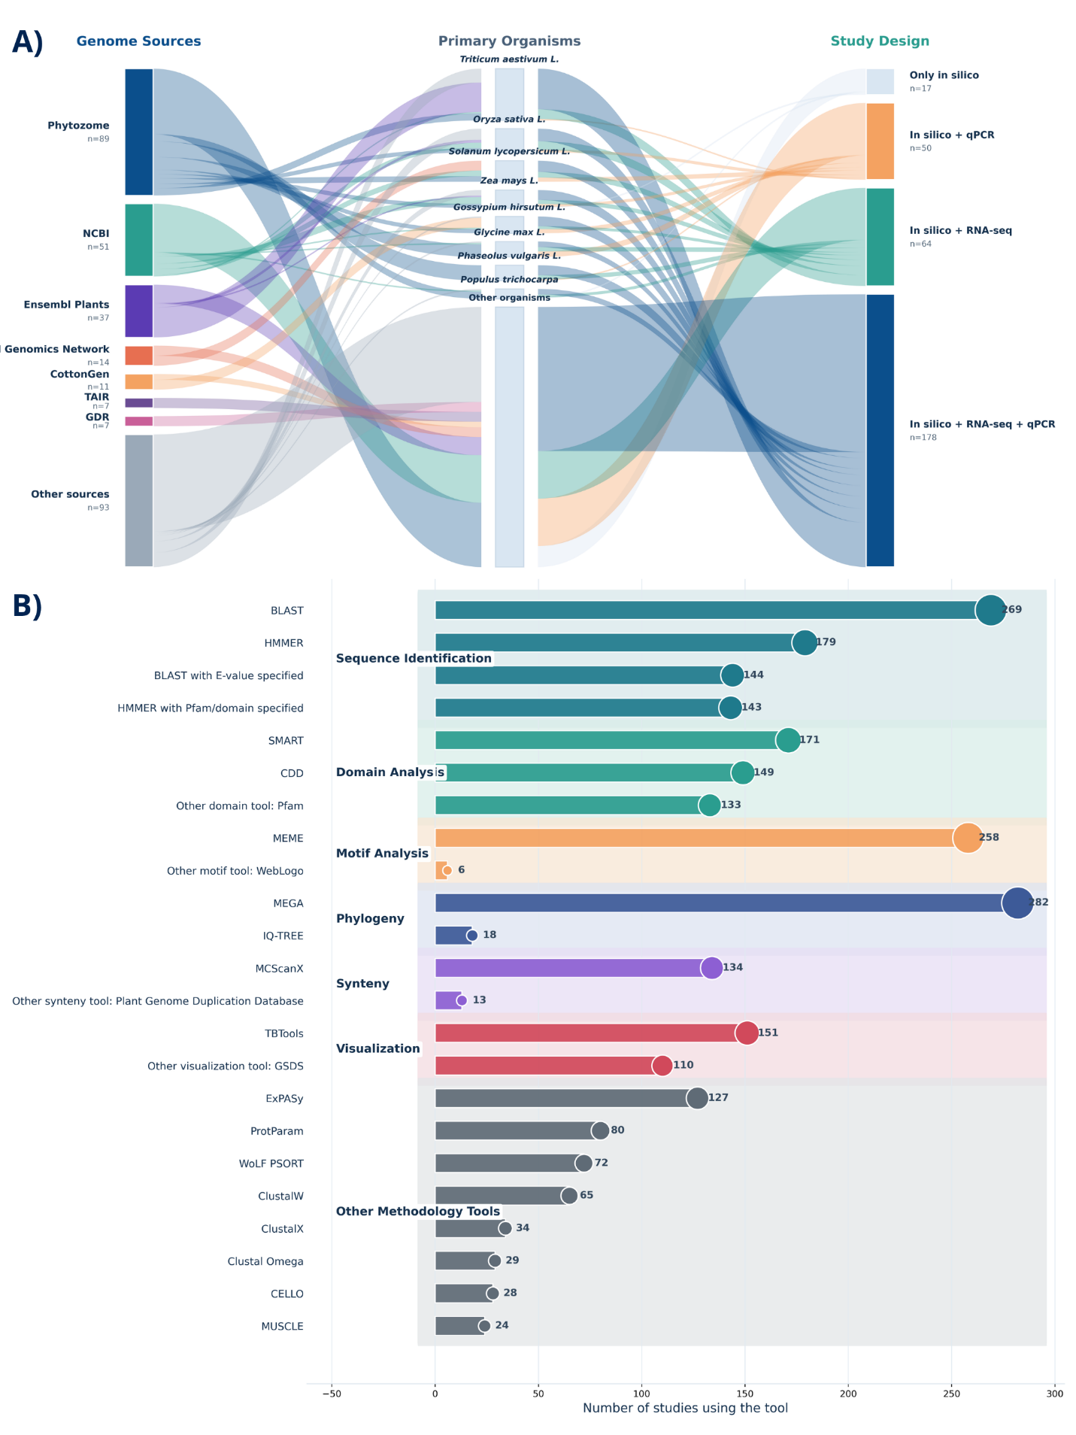
Figure 9. Genomic pipeline complexity and tools usage. (A) A Sankey flow diagram represents the usage flow of genome sources to major organisms and study designs. (B) Bar plot represents the annual usage of tools frequency, indicating the exponential growth of special bioinformatics software (MEGA, BLAST, MEME).

